**FPT ACADEMY INTERNATIONAL**

**FPT**

**–**

**APTECH**

**COMPUTER EDUCATION**



**Centre Name: ACE-HCMC-2-FPT.**

**Address: 590 Cach Mang Thang 8, District 3, Ho Chi Minh City, Viet Nam.**

**FIRST FASHION**

|  |  |  |
| --- | --- | --- |
| **Supervisor** | PHAM THI LANH |  |
| **Semester** | 1 |  |
| **Batch No** | T1.2103.M0 |  |
| **Group No** | 5 |  |
| **Order** | **Full name** | **Roll No.** |
| 1. | PHAM TRAN HAI NAM | Student2103008 |
|  |  |  |
|  |  |  |

Month 06 Year 2021



This is

to cert

ify that

Mr:

Pham Tran Hai Nam

Has successfully Designed & Developed

**FIRST FASHION**

Submitted by:

Pham Thi Lanh

Date of issue:

July, 18

th

2021

Authori

zed Sign

ature:

**CONTENTS**

ACKNOWLEDGEMENT 5

SYNOPSIS 5

REVIEW 1 7

REQUIREMENT SPECIFICATION 8

PROBLEM DEFINITION 9

CUSTOMERS REQUIREMENT SPECIFICATIONS (CRS) 9

1.Client: FIRST FASHION 9

2.Business/Project Objectives: 9

3.Inputs provided by clients: 10

4.Hardware Requirement: 10

5.Software Requirements: 10

ARCHITECTURE & DESIGN OF THE SYSTEM 11

SITEMAP 12

WEBSITE LAYOUTS 12

1. Homepage: 12

2. Informative pages: 14

3. Shopping page 15

4. Product detail 16

5. About 16

6. Contact 17

7. Sign in 17

8. Registration 18

TASK SHEET 1 18

REVIEW 2 20

WEBSITE INTERFACE 21

1.Home page 21

2. Shop Page 23

3. Contact us 24

4. Sign Up 25

5. Sign in 25

6. About us 26

7. Product detail ( 1 – 12 same design just change product and description) 26

TIME MANAGEMENT 27

TASK SHEET 2 28

CHECKING VALIDATION 29

# 

# ACKNOWLEDGEMENT

I would like to acknowledge all those who have given moral support and helped in making the project a success.

I wish to express my gratitude to the e-Projects Team at the Head Office, who guided and helped me. I would also like to express my gratitude to all the staff members of my center for not only providing me with the opportunity to work with them on this project, but also for their support and encouragement throughout the process.

I also express my sincere gratitude to the e-Projects Team at the Aptech Head Office and my project guide at the organization, for her valuable guidance and support for the completion of this project.

And finally, I would like to offer many thanks to all my colleagues for their valuable suggestions and constructive feedback.

# SYNOPSIS

First Fashion is a company that distributes products from famous brands in Vietnam established since 2010. First Fashion has a chain of stores from Hanoi to Ho Chi Minh providing fashion products from famous brands.

The important menu must be stated in the top section of the webpage. Also a decent look out and color combination is expected.

The website is to be developed for the Windows Platform using HTML5, JavaScript and Bootstrap. The site should work well in all leading browsers including Chrome, IE, Firefox.. , the site can display by different devices such as mobile phone, tablet, personal computer, …

REVIEW 1

# REQUIREMENT SPECIFICATION

**The Web site is to be created based on the following requirements.**

1. The home page with description about First Fashion like what is First Fashion, display some main contents similar to others regular fashion web, example: new products, best sellers, trending ,…
2. The website must provide information like: “Home”, “Brands”, “Social media buttons”, “About us”, “Contact”, ” Sign in”, Currency Unit ,”Faqs”, Carousel with contents, Event options like “Best sellers”, “New Arrivals”, “Hot Sales”, Fashion’s brand special
3. “Home”, “Brands”, “About us”, “Contact”, “Carousel arrow”, Contents in carousel, “Sign in”, “Best sellers”, “New Arrivals”, “Hot sales”, Contents in “Fashion’s brand special” must contained event and actions.
4. Each section much provided brief information.
5. Each link, button must be properly hyperlinked and show right cursor, images must be used wherever necessary.
6. Contact us bring user to a page that user can input information to contact with the company.
7. About us will bring user to a page that have description about the company.
8. Sign in button will bring user to Login page, Login page provide input account and Sign up option, Sign up option will bring user to Registration form.
9. Carousel have next and previous button that user can use to review main contents of company. Content in Carousel section must change when click to arrow button.
10. “Fashion’s brand special” section provided some certain products of each brand attach image of product, date, title of thread, read more. User can click to read more to access page that describe chosen product.
11. Footer contained logo of company, slogan under the logo, vertical navigation bar included “Shop”, Event”, “About Us”, Telephone numbers, Address, “NEWLETTER” for user to give email to receive news, sale off, event from First Fashion.

# PROBLEM DEFINITION

After reading the project specifications, the developer states the scope of the project very briefly. This is referred to as the problem definition. Queries of various staff members can be one or all of the following:

1. How many products can be displayed on Homepage at a time?
2. How to soft products by using brand’s name?

After consulting several IT companies and considering the budget constraints, the management of First Fashion to launch the Web application as a single page responsive Web application using HTML5, CSS3, JavaScript, Geolocation API, Web Storage, and Bootstrap 3.3 from getbootstrap.com, jQuery plugins, Javascript and Geolocation. Also, the site will be tested on popular browsers and mobile emulator software.

# CUSTOMERS REQUIREMENT SPECIFICATIONS (CRS)

## 1.Client: FIRST FASHION

## 2.Business/Project Objectives:

Provide a website to displays the programs and services about Fashion products such as: “About us”, “Shop”, “Currency Unit”, “Best sellers”, “New Arrival”,

“Contact Us”, …

Enable customers to see what event that they would like. Easier interactive with us.

## 3.Inputs provided by clients:

Inputs to the existing system.

Outputs from the existing system.

Process involved in the application.

## 4.Hardware Requirement:

* A minimum computer system that will help you access all the tools in the courses is a Pentium Dual core or better
* 256 Megabytes of RAM or better

## 5.Software Requirements:

* Visual studio code
* Notepad++
* Chrome

# ARCHITECTURE & DESIGN OF THE SYSTEM

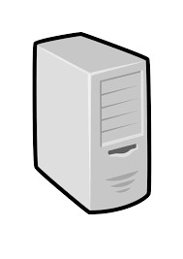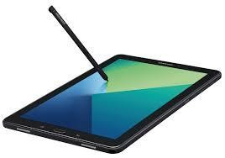

**CLIENT**

**SERVER**



Font End technologies

(

HTML5, CSS3, Bootstrap, Javascript)

# SITEMAP

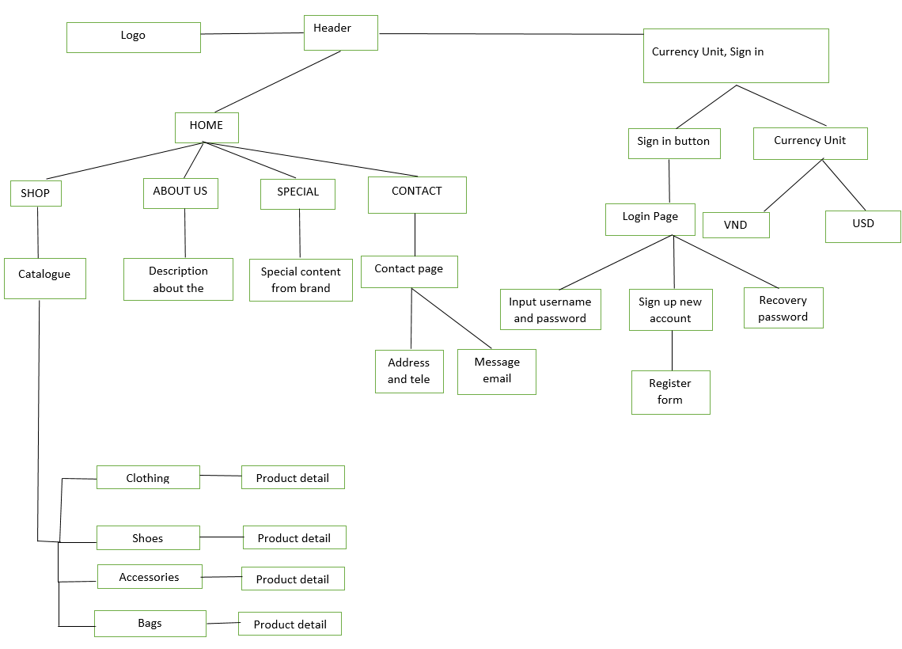

# WEBSITE LAYOUTS

**Here are our layouts which will show you how we brainstormed ideas for the Fashion web pages. Because of being academic website, we tried to build them SIMPLE but USEFUL and INFORMATIVE as much as possible.**

**The website is going to have several pages which include different information in the same main layout.**

## Homepage:

This layout below describes how we created our Homepage which contain three important parts:

* *Page-header and Navigation bar:*

Page-header must have shipping description and return, refund option, account. Sign in link will get user to login page, Currency Unit drop down options VND and USD.

Navigation bar is one of the most crucial sections in the whole website which will indicate people how they interact with us. It provided some information like Home, Shop, Event, About us, Contact, Search icon, favorite icon, cart icon. Each section must have brief information.

* *Carousel:*

This part is customized to have next and previous arrow to change content appeared in middle of 2 arrow, the content is a product of a brand display by image and have short description.

* *Tags:*

“Best sellers”, “New arrivals”, “Hot sales” are the tags that user can click on to soft products displayed under these tags. Products displayed by image and have hover event to show “Add to cart”, “Favorite”, “Compere” will show up when user move cursor to it.

* *Brand’s specials:*

This section provided 3 threads, each thread consumed one product of a brand with posting date, thread’s title, and read more button.

* *Footer:*

Logo and the slogan of First Fashion under it.

The final part of all our websites is definitely Footer which will reveal some convenient ways to contact the shop in different social channels like Email, Facebook, Twitter, Instagram, …

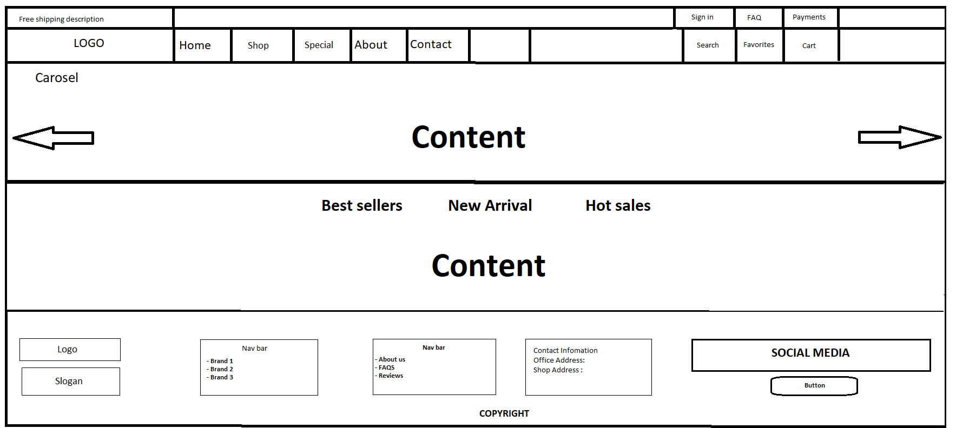“NEWLETTER” for user to give email to receive news, sale off, event from First Fashion.

## Informative pages:

This layout we will apply for most of other pages (Contact us, Shop, Special...) which provide people different information about the First Fashion products. It also has the same Page-header, Navigation bar and Footer as Homepage, but the main content is changed.

## Shopping page

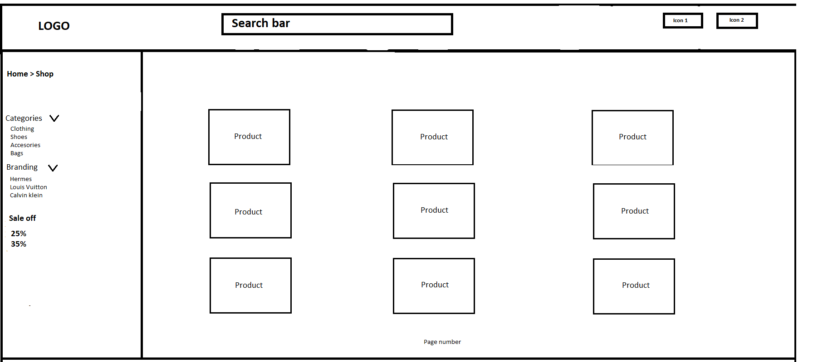

In this page I will add 9 – 12 product showed up by image, each image will have hover event to show “Compere”, “Favorite”, “Add to cart”, “Compere” Button allow user to compere chosen product with another product.

The shopping page will have a completed category design. But only the options of “Branding” can be choose to soft products by brand.

## Product detail

This page very simple. Provided picture of product and some descript tion about product.

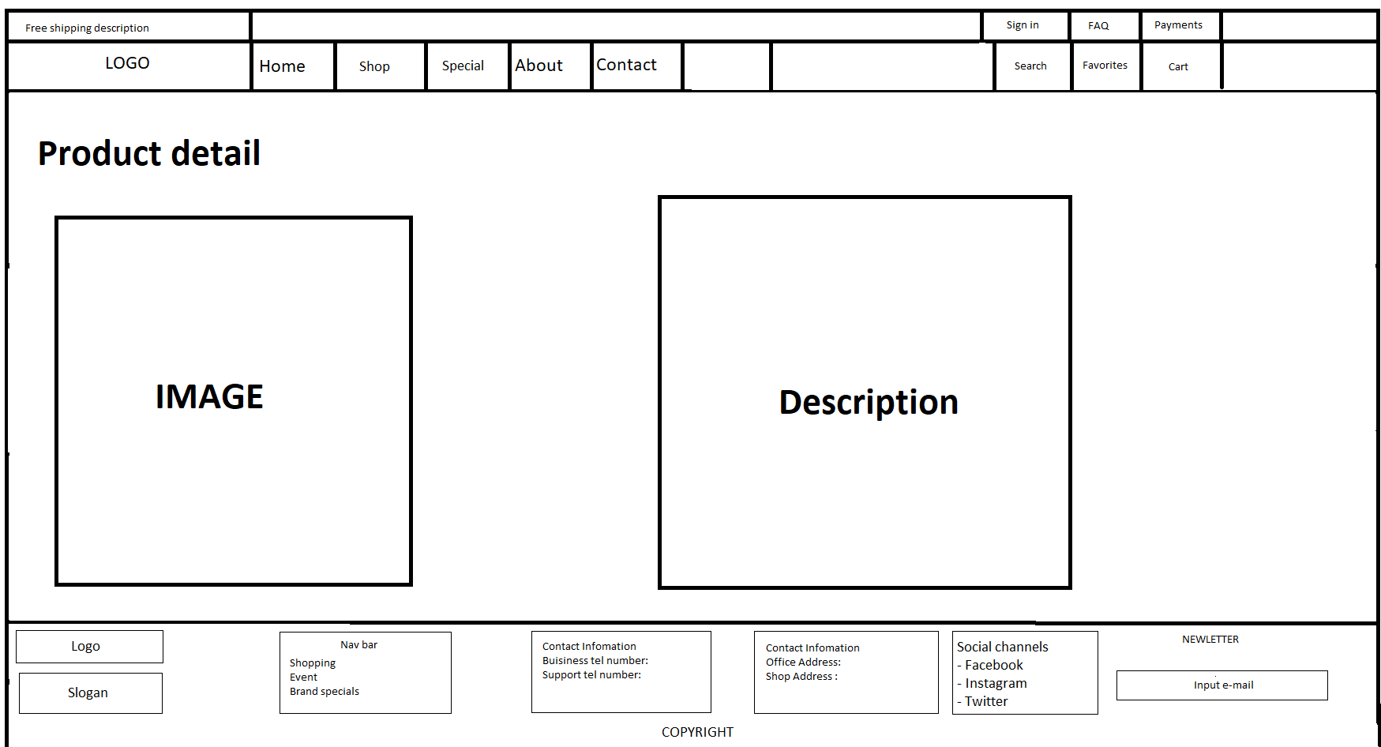

## About

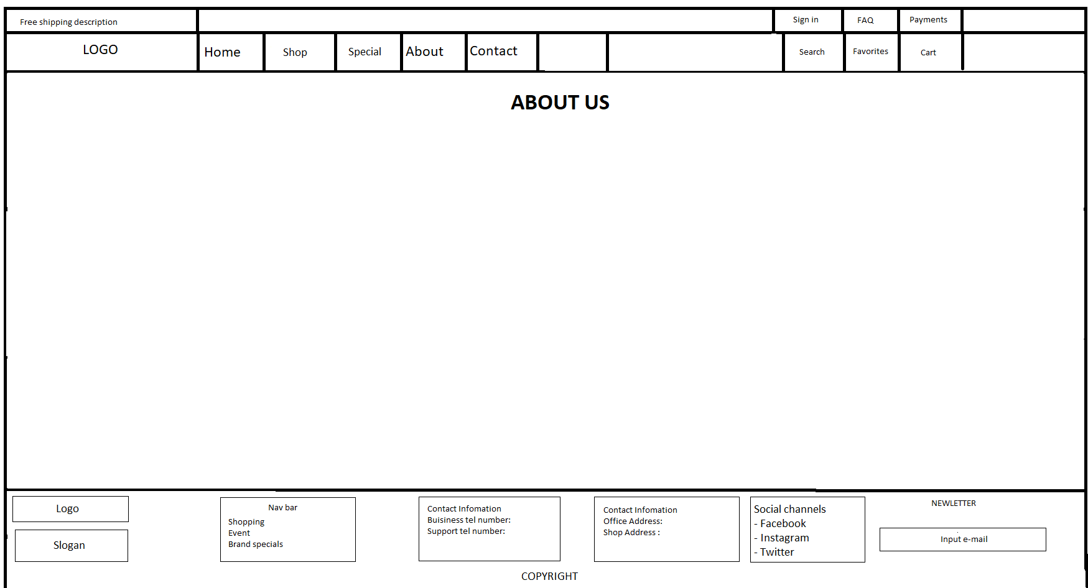Similar to special, in this page I added some image about fashion pictures of which brand I have. Description about First Fashion like: What are we, history, information about what we’re selling, our goal, how we understand customers….

## Contact

Geolocation API will be added to locate the address of company.

Input “Subject”, “Your name”, “Your e-mail”, text-area are included.

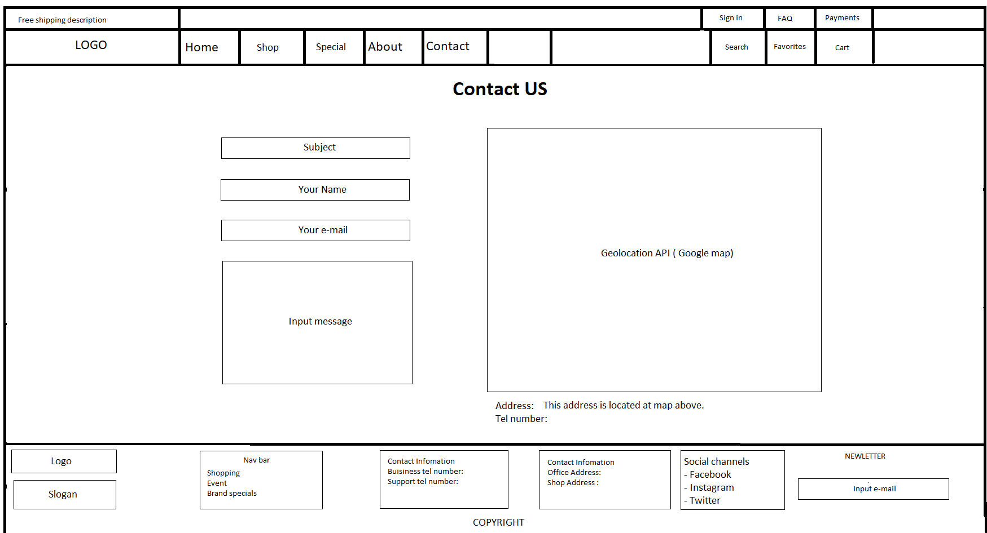

## Sign in

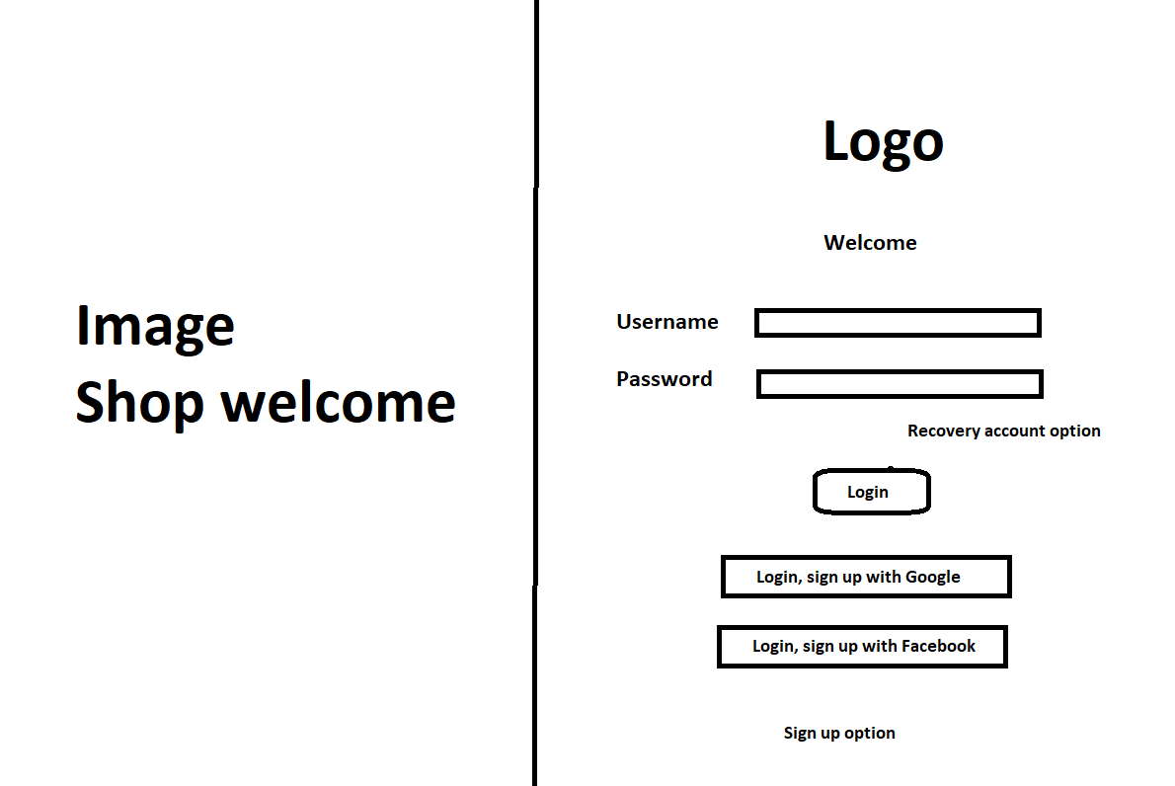

Sign in page designs basically with regular form, contained Logo of the company, Welcome image, in put username and password, recovery password, others log in option via google and FB. Sign up option is a take user to a registration form.

## Registration

Basic register form

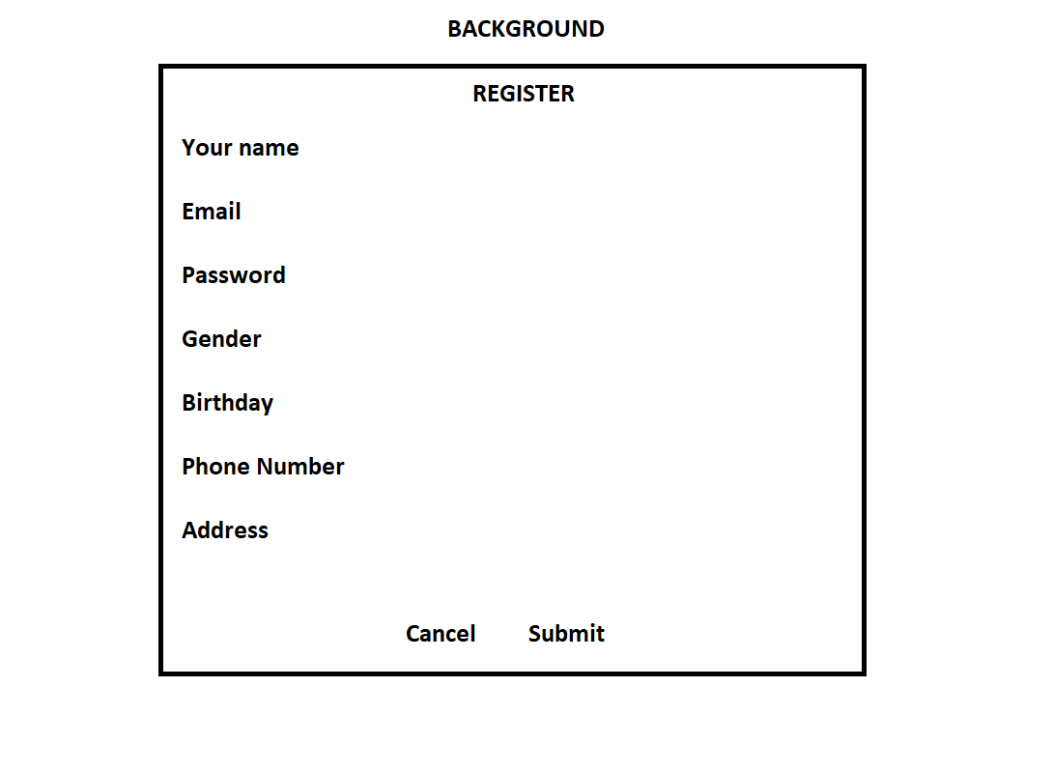

# TASK SHEET 1

|  |  |  |  |  |  |  |
| --- | --- | --- | --- | --- | --- | --- |
| **Project Ref. No.** | **Project Title** | **Activity**  **Plan**  **Prepared by** | **Date of Preparation of Activity Plan** | | | |
| **Task** | **Actual Start**  **Date** | **Actual**  **Days** | **Teammate**  **Names** | **Status** |
| Create layouts for website base on group discussion ideas | FIRST FASHION | Nam | 11/06/2021 | 4 |  | Completed |
| Draw layouts using  Paint | FIRST FASHION | Nam | 17/06/2021 | 3 |  | Completed |
| Write project  report 1 | FIRST FASHION | Nam | 17/06/2021 | 1 |  | Completed |
| Homepage design and coding  (include navigation bar and footer) | FIRST FASHION | Nam |  |  |  |  |

|  |  |
| --- | --- |
| Signature of Faculty | Signature of Leader Team |
|  |  |

REVIEW 2

# WEBSITE INTERFACE

## 1.Home page

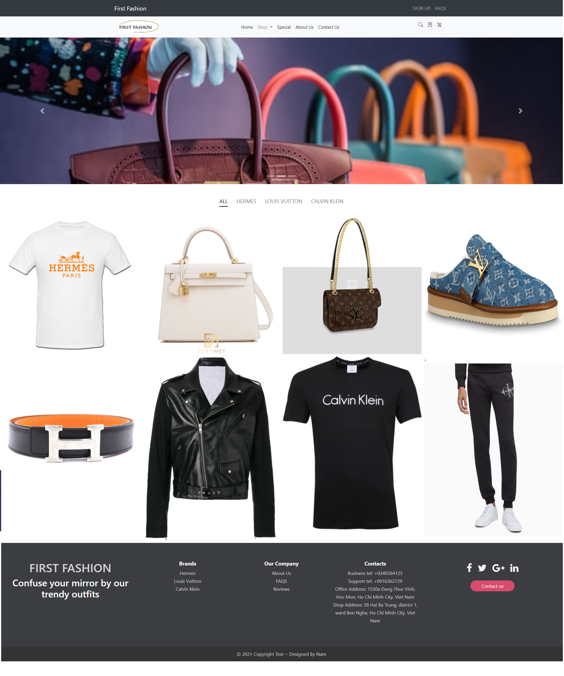

-When user/ customer hover the shop will drop down brand name link to the shop.

- When user/ customer click to brand name it will soft products by brand.

|  |  |
| --- | --- |
| Title | Decsription |
| Home | * Carousel show some contents * Filter will soft products display by brand * Top Nav bar contained “FAQS”, “SIGN UP”- link to register page, “SIGN IN”- link to login page. * Nav bar contained “Shop”(dropdown brands name), “About us”- link to About us page, “Contact us” link to contact page, “Special. * “First fashion” text from header and footer link to home page. * Logo link to home page * Facebook logo link to Nam’s facebook. * “Contact us” button on footer link to contact page. * “Office address” and “Shop address” link to marked location on google map. |
| Contact us | * Included header and footer from Home page. * Google geolocation API. * Input box required. |
| About us | * Included header and footer from home page. * Description about company. |
| Shop page | * Filter added. * “Home” link to Home page. * Every product link to it own detail page. |
| Resgister | * Basic register from without effects. * “Cancel” link to home page. |
| Login | * Basic login page. * Input is required * “Back to home page” link to home page * “Sign up” link to register page |
| Product detail ( 12 pages ) | * Footer and Header from home page. * Hover to image to zoom. |

## 2. Shop Page

- When user click to any brand name in shop-dropdown and footer will get to shop page.

- Shop page display some product. User can click to product image to get to product detail page.

- Filter have been added effect to soft products by it type.

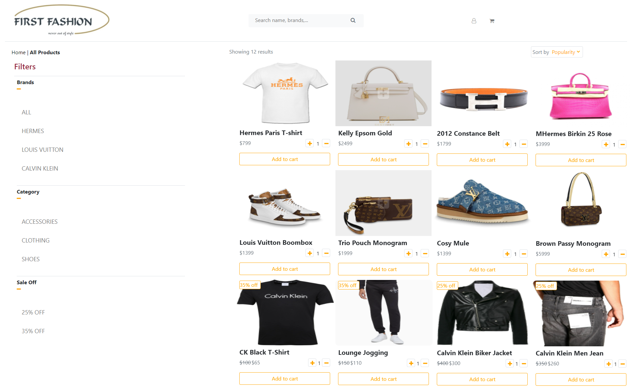

## 3. Contact us

- When you click to Contact Us link in the Homepage, this page below will show you map to the office of company with Geolocation API and main contact information.

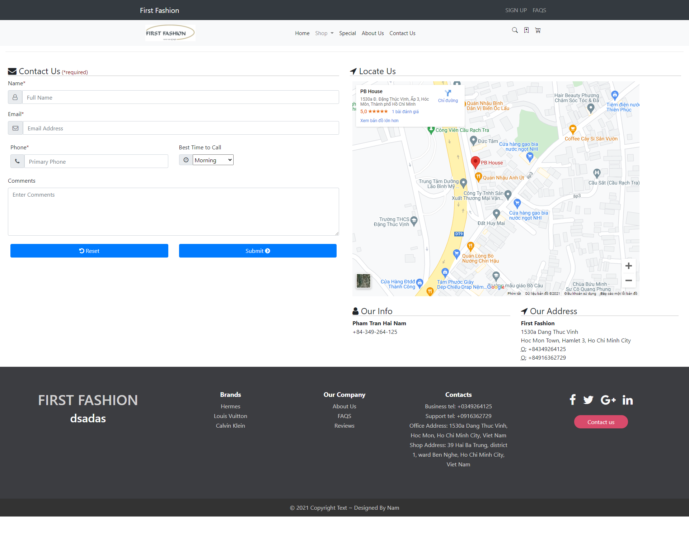

## 4. Sign Up

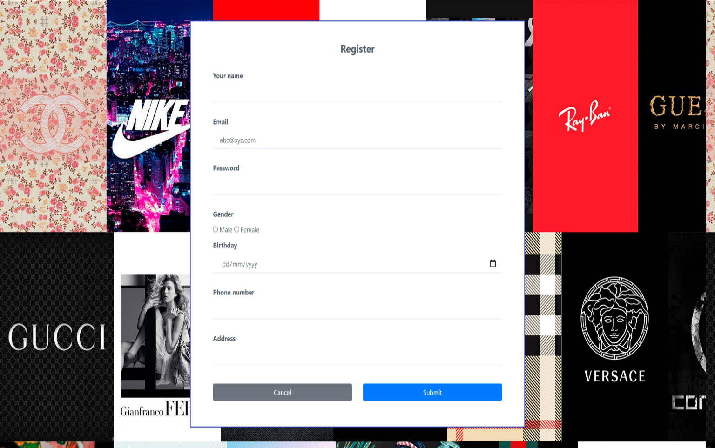

## 5. Sign in

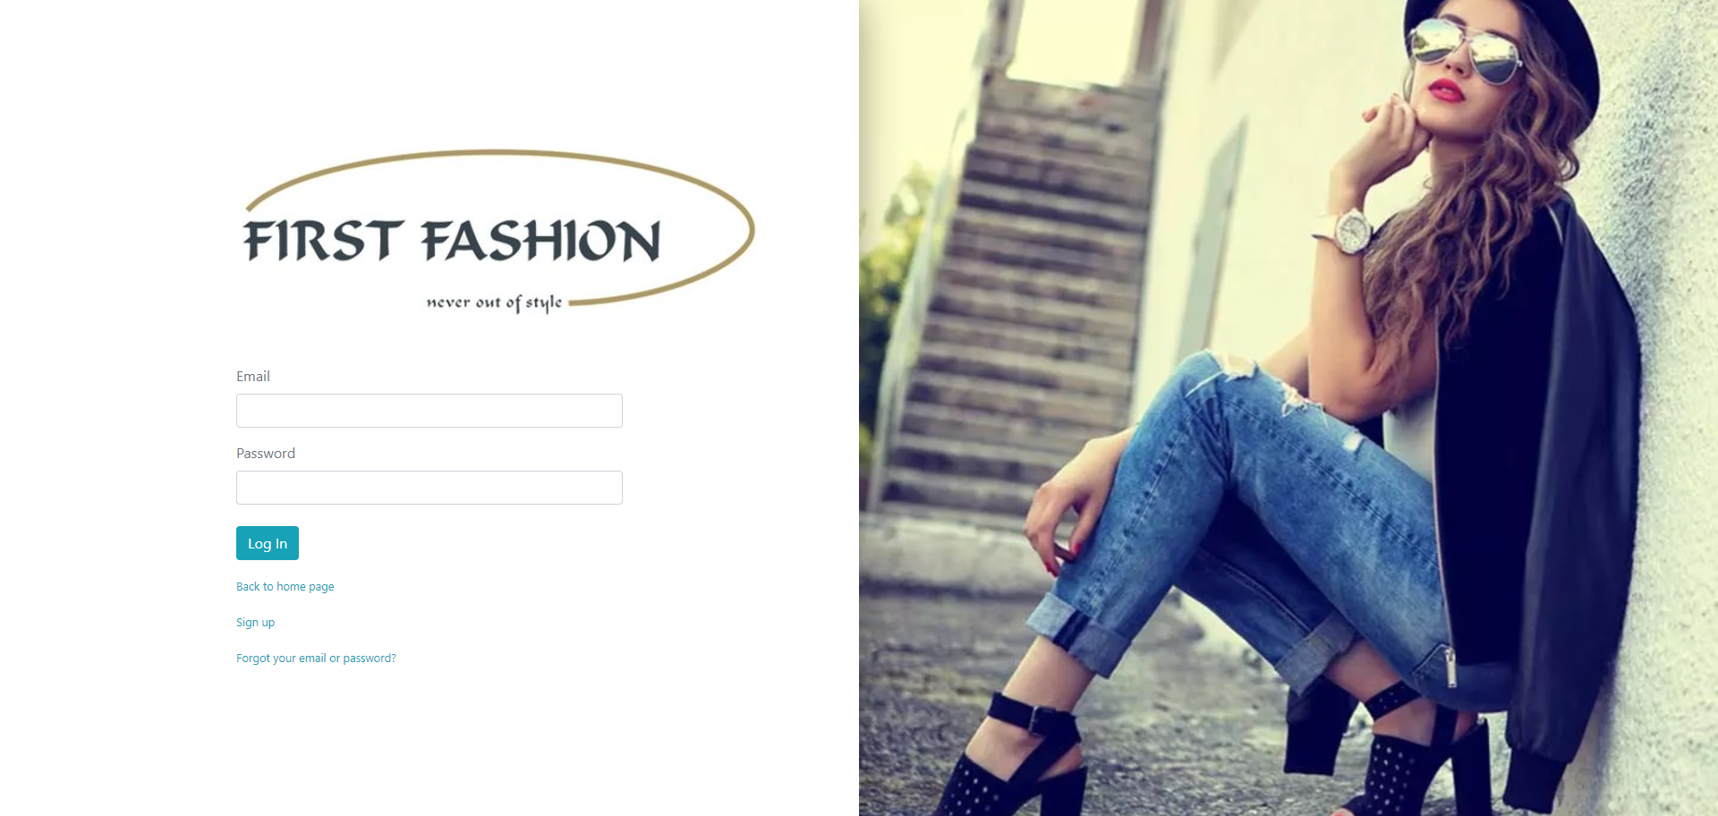

## 6. About us

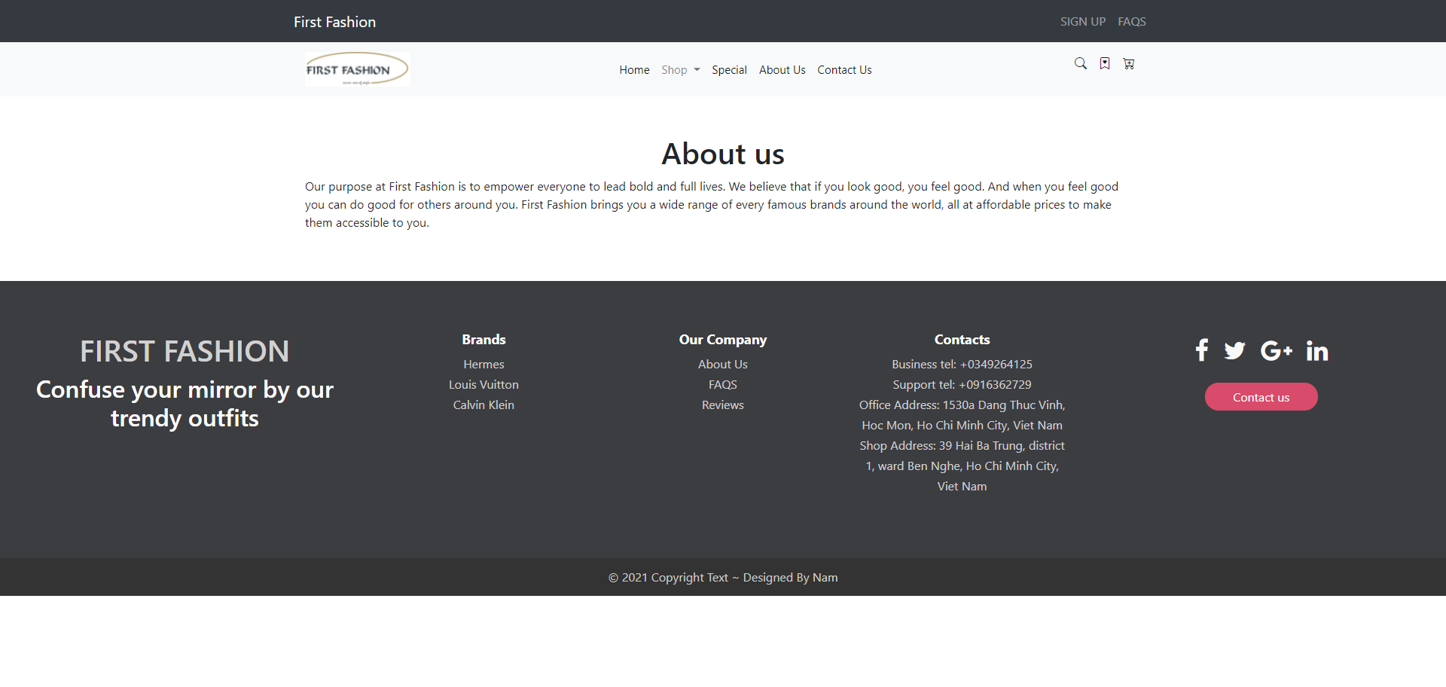

## 7. Product detail ( 1 – 12 same design just change product and description)

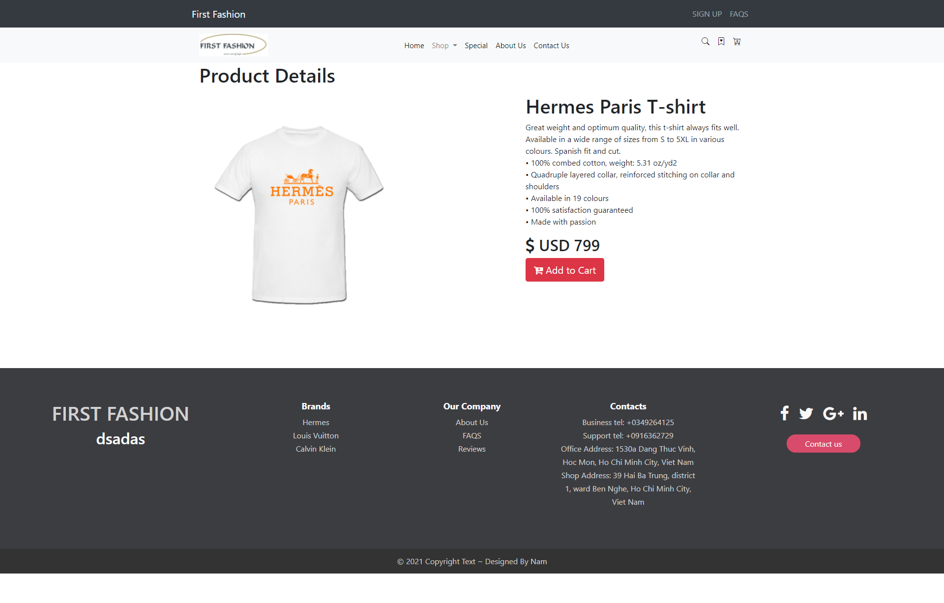

# TIME MANAGEMENT

**STATE 2**

* Collect images, details.
* Build website ( HTML, CSS, JS, BS)
* Group website with links.
* Write project report.

**STATE 1**

* Making Ideas.
* Create layout.
* Research information and design by some ecommerce fashion web site.

**STATE 3**

* Edit and checking everything.
* Testing.
* Write final report.

# TASK SHEET 2

|  |  |  |  |  |  |  |
| --- | --- | --- | --- | --- | --- | --- |
| **Project Ref. No.** | **Project Title** | **Activity**  **Plan**  **Prepared by** | **Date of Preparation of Activity Plan** | | | |
| **Task** | **Actual Start**  **Date** | **Actual**  **Days** | **Teammate**  **Names** | **Status** |
| Design Contact us page with Geolocation API and coding | FIRST FASHION | Nam | 25/06/2021 | 1 |  | Completed |
| Design shop page with filter and effect, research pictures and content, coding. | FIRST FASHION | Nam | 27/06/2021 | 5 |  | Completed |
| Design sign up and sign in page, coding. | FIRST FASHION | Nam | 30/06/2021 | 1 |  | Completed |
| Checking all things, fixing bugs, re-design,… | FIRST FASHION | Nam | 31/06/2021 | 10 |  | Completed |
| Write review 2 | FIRST FASHION | Nam | 15/07/2021 | 2 |  | Completed |

# CHECKING VALIDATION

|  |  |  |
| --- | --- | --- |
| **TASK** | **Requirement** | **Validation** |
| 1 | The Home Page should be created making use of Sections with a suitable logo. | Yes |
| 2 | Home Page should contain details of fashion products with suitable images. | Yes |
| 3 | The site should display a menu which will contain the options for brief introduction about the various fashion products available, location of the shop and any other information if required. | Yes |
| 4 | The information should be categorized according to the brand names of the products like if a User wants to see only “LAKME” products or any other companies products then he/she can click on a Link/button/menu etc and can see only that Brand products. | Yes |
| 5 | When a user selects any particular brand, a list of products for that brand will be displayed | Yes |
| 6 | A brief summary of features of individual products should be displayed on the Web Page along with the product but detailed Features should be stored in Individual Word documents which can be downloaded or viewed by the User who wishes to see the same. | Yes |
| 7 | The user should also be able to compare the various products of different as well as similar brands. | No |
| 8 | There should be a “Contact Us” page which will have the Address of the Company which is as follows and the mail address which when clicked will invoke the local mail client from where they can send an email. Address of the Company should be displayed using GeoLocation API (eg. GoogleMaps). | Yes |